**BLG368E - Object Oriented Modeling and Design**

**Assignment 3**

Kadir Emre Oto (150140032)

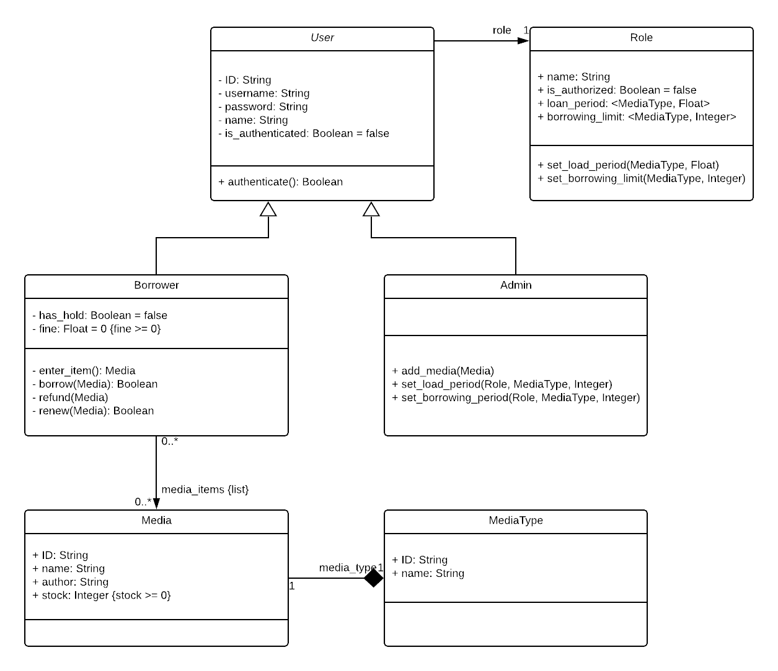

Figure 1: Design Class Diagram

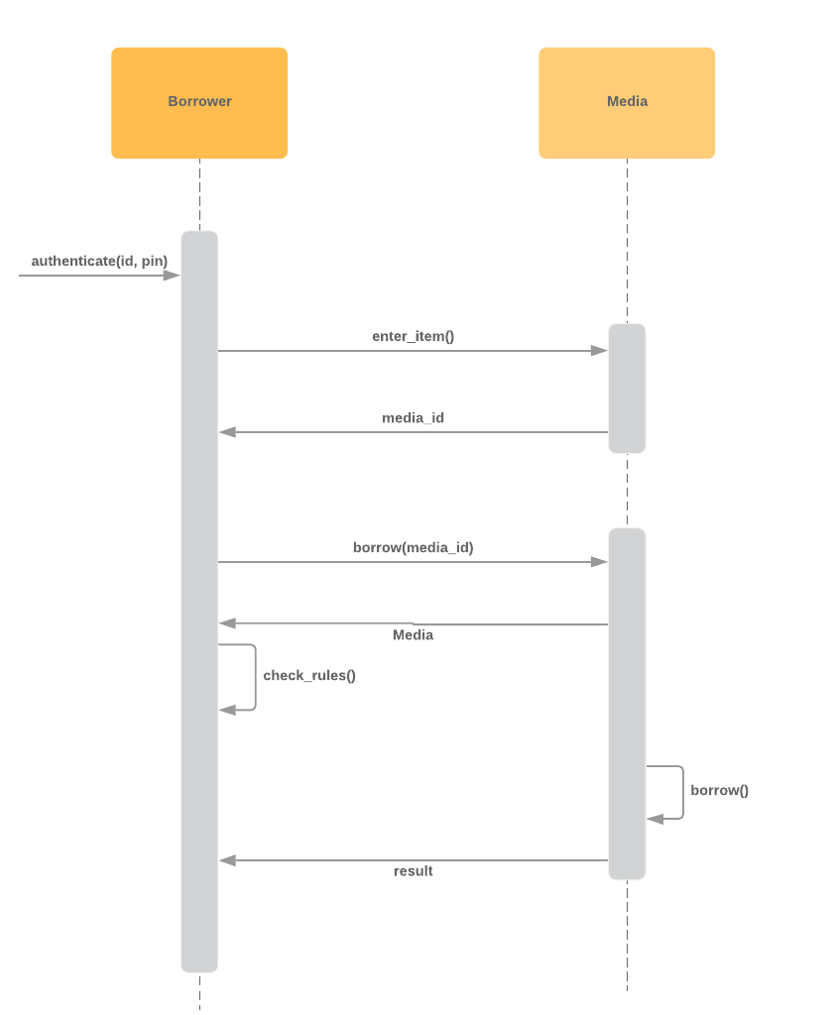

Figure 2: Sequential Interaction UML Diagram